Catalase Enzyme Reaction Student Experiment - Eden Tomes

# Research Question:

How does increasing the volume of catalase solution (representing different enzyme concentrations) affect the rate of oxygen gas production when reacting with a constant volume and concentration of hydrogen peroxide?

# Rationale:

Cells, the fundamental units of life, depend on a multitude of biochemical reactions for survival and function, collectively known as metabolism (*Biology LibreTexts*, 2016). Many of these essential reactions would occur too slowly to sustain life without biological catalysts called enzymes (*Cooper*, 2000). Enzymes, primarily proteins, accelerate reaction rates by lowering the activation energy. They achieve this by binding to specific reactant molecules, or substrates, at a region called the active site, facilitating their conversion into products (*Robinson*, 2015).

Catalase is a crucial enzyme found in nearly all aerobic organisms, playing a vital protective role. It catalyses the decomposition of hydrogen peroxide (H₂O₂), a toxic byproduct of cellular metabolism, into harmless water (H₂O) and oxygen (O₂) (*Zamocky et al.*, 2008). This detoxification prevents oxidative damage to cellular components, a key aspect of how cells maintain homeostasis (*Nandi*, 2019).

The rate of enzyme-catalysed reactions is influenced by factors such as temperature, pH, substrate concentration, and enzyme concentration (*Robinson*, 2015). While a previous experiment explored temperature effects, this investigation focuses on how varying enzyme concentration impacts reaction rates. According to established enzyme kinetics, when substrate is abundant, the initial reaction rate is directly proportional to the enzyme concentration (*Aebi*, 1984). This is because more enzyme molecules mean more active sites are available to process the substrate, leading to faster product formation (*Robinson*, 2015).

This experiment aims to systematically investigate how altering the volume of catalase solution, thereby changing its effective concentration, affects the initial rate of oxygen production from hydrogen peroxide decomposition. By keeping substrate concentration, volume, and temperature constant, the study will isolate the influence of enzyme quantity on reaction rate. This will provide insight into how cells can regulate metabolic pathways by controlling enzyme availability.

# Methodology:

## Original Experiment

The original method measured the oxygen release of hydrogen peroxide decomposition 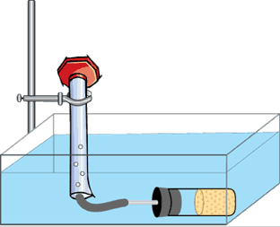

## Modifications

The modified experiment redirected the aim of the original investigation to examine the influence of enzyme amount on the rate of decomposition

## Safety & Ethical Considerations

|  |  |  |
| --- | --- | --- |
| **Hazard** | **Identified Risk** | **Control Measure(s)** |
|  |  |  |
|  |  |  |
|  |  |  |

# 

# Processed Data + Calculations:

A

Figure 1 – Results Table: Volume of Oxygen Present After 300 Seconds  
(values are in mL and rounded to 2 decimal places)

|  |  |  |  |
| --- | --- | --- | --- |
|  | **1mL Catalase** | **2mL Catalase** | **4mL Catalase** |
| **Trial 1** | 4.00 | 0.70 | 11.00 |
| **Trial 2** | 3.00 | 5.00 | 8.50 |
| **Trial 3** | 0.70 | 5.00 | 4.50 |
| **Mean:** | 2.57 | 3.57 | 8.00 |
| **Std Dev.** | 1.38 | 2.03 | 2.68 |
| **Std Error** | 0.80 | 1.17 | 1.55 |
| **Upper Limit** | 5.33 | 7.62 | 13.35 |
| **Lower Limit** | 0.00 | 0.00 | 2.65 |

Figure 2 – Column Graph:

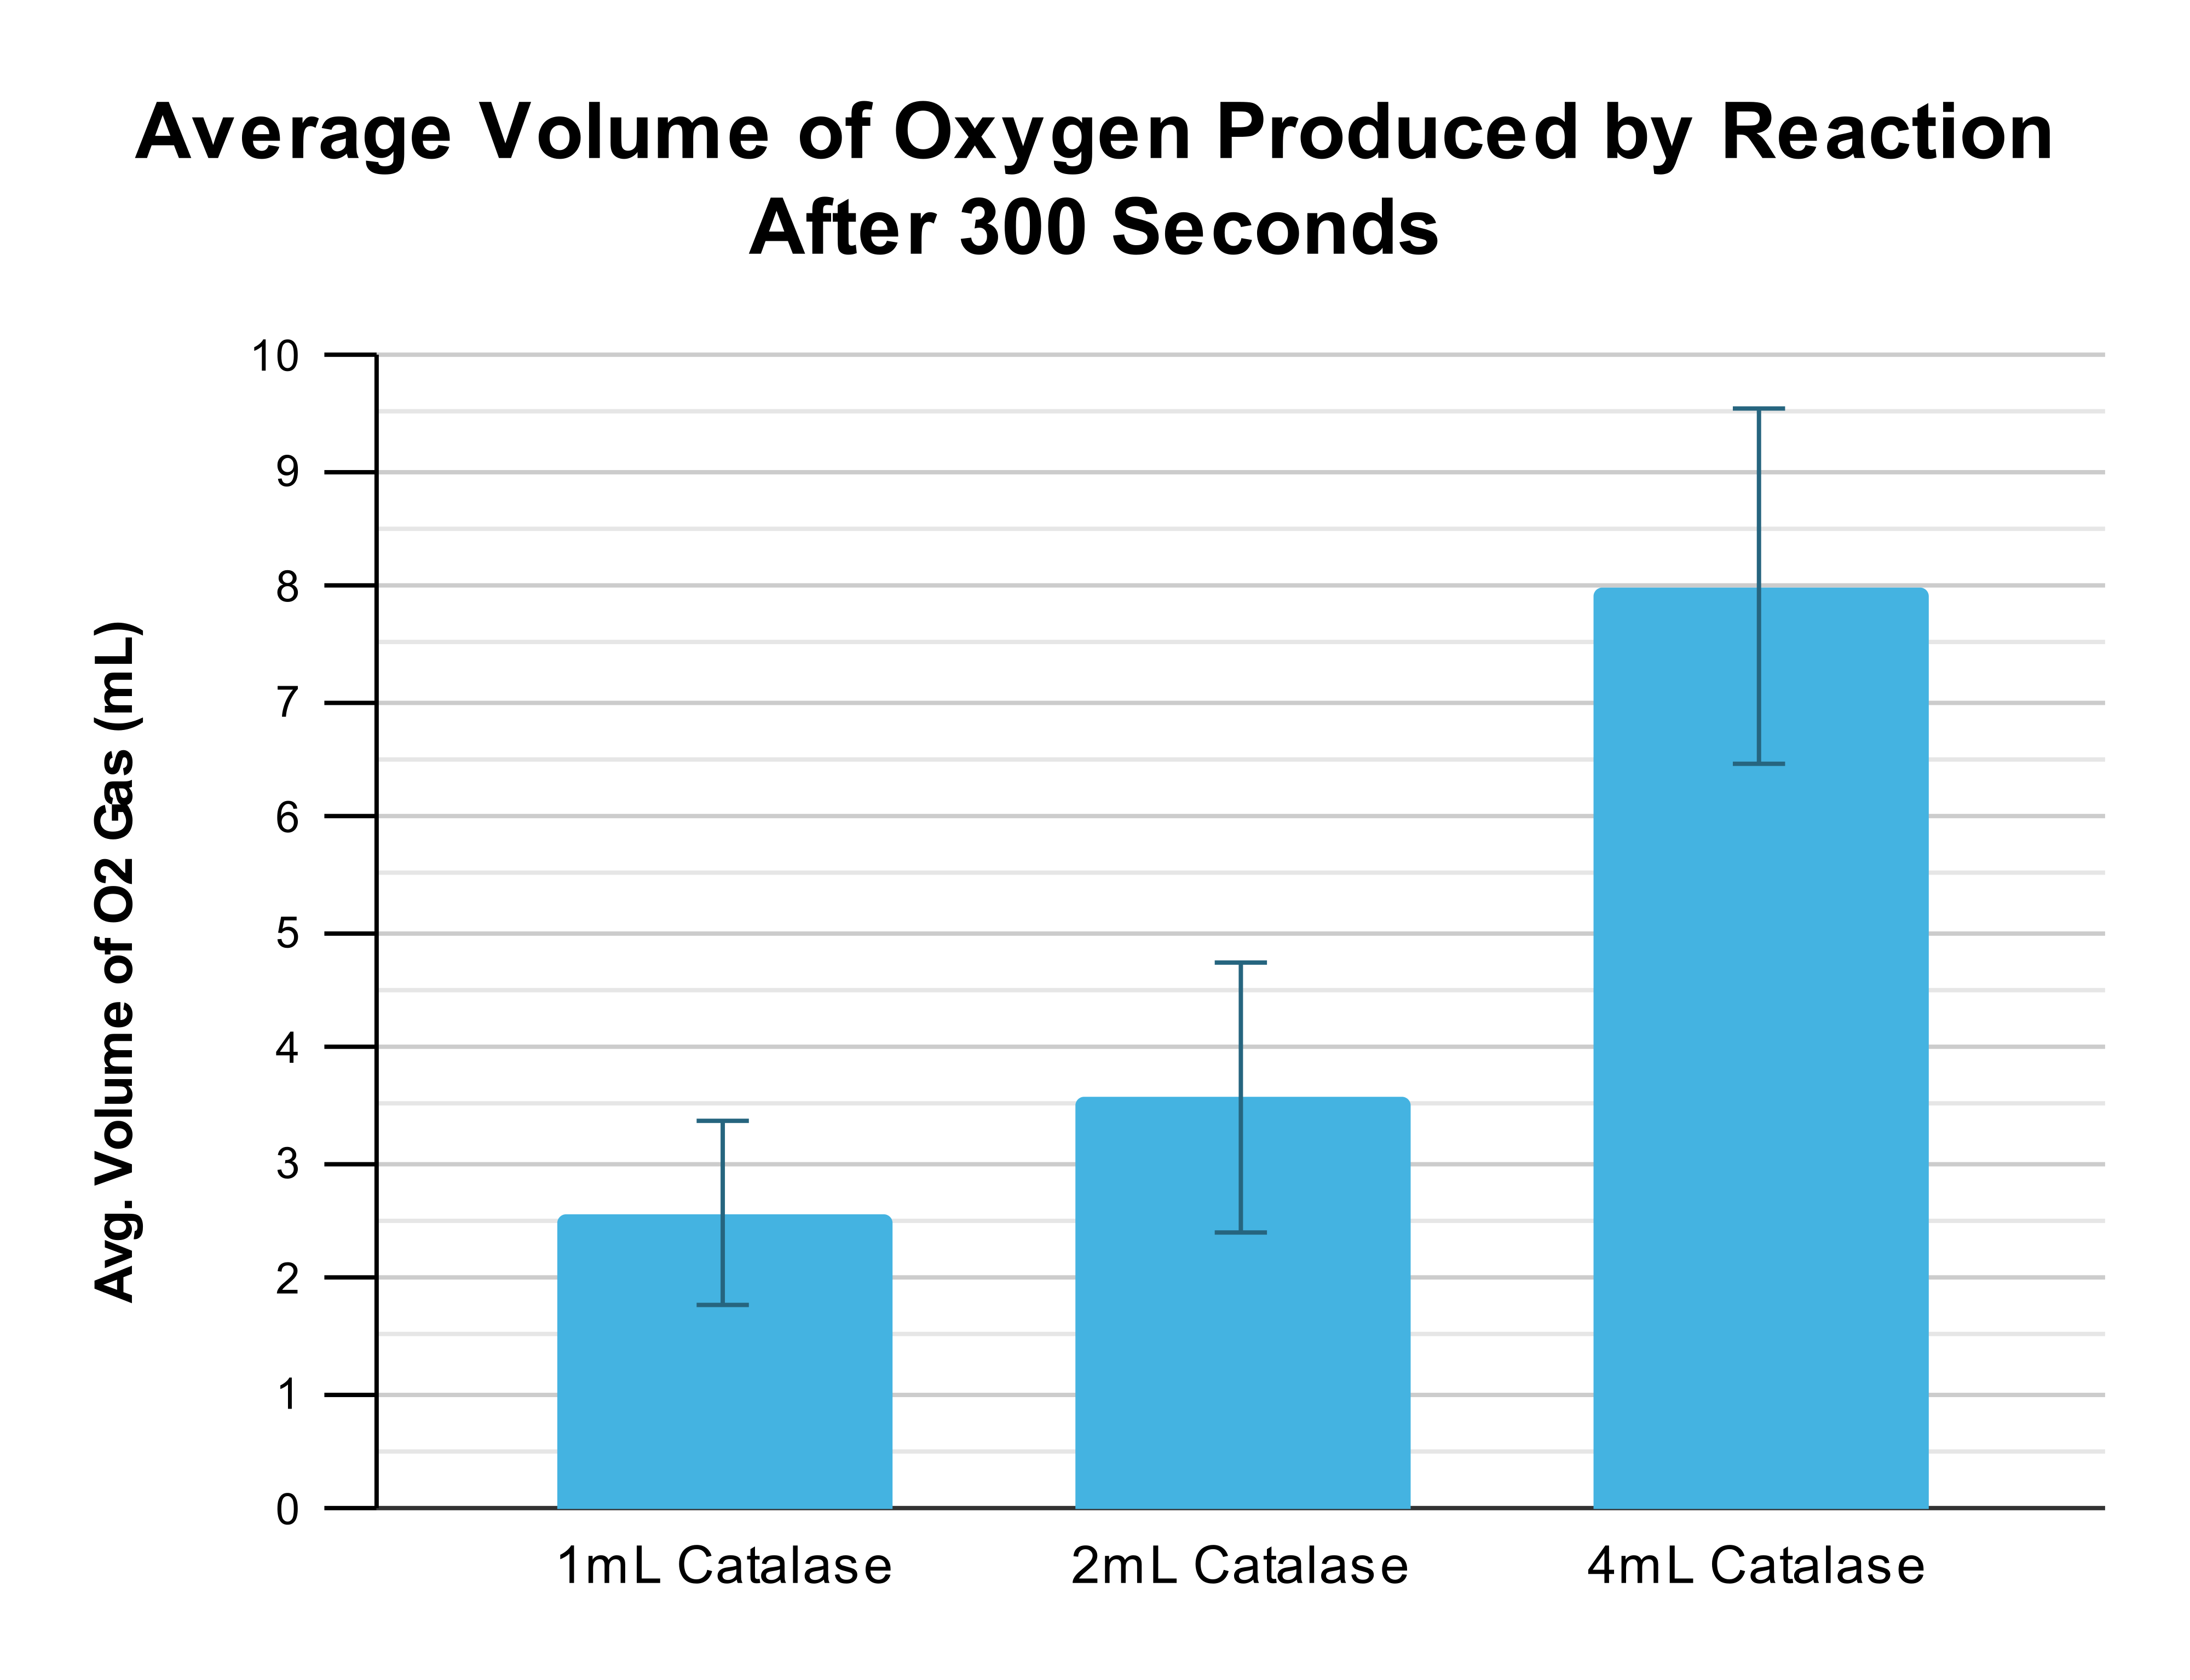

Figure 3 – Line Graph:

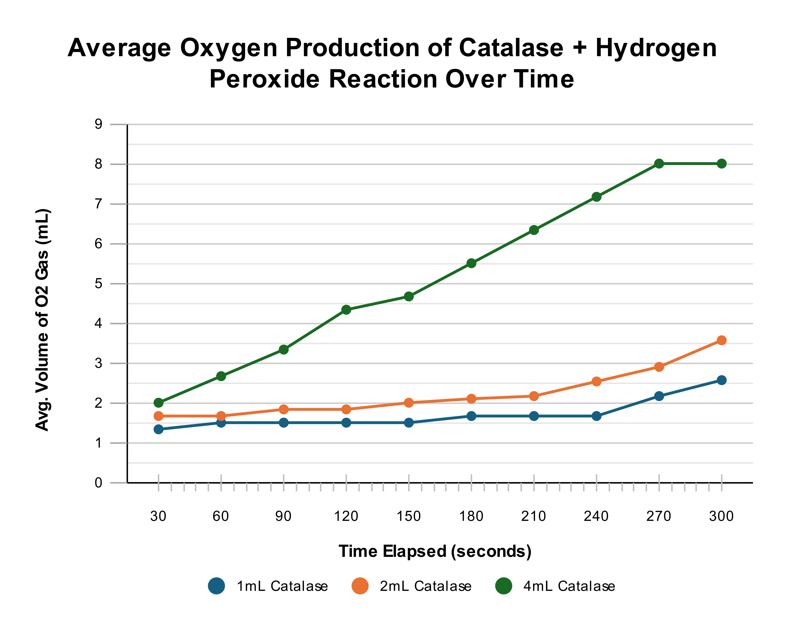

# Analysis of Evidence:

A

# Evaluation:

## Sources Of Error Affecting Reliability

A

## Sources Of Error Affecting Validity

A

## Suggested Improvements & Extensions

A

# Conclusion:

A

# Reference List:

* Aebi, H. (1984). Catalase in vitro. *Methods in Enzymology*, [online] 105, pp.121–126. doi:[https://doi.org/10.1016/s0076-6879(84)05016-3.](https://doi.org/10.1016/s0076-6879(84)05016-3)
* Biology LibreTexts. (2016). *1.16: Types of Biochemical Reactions*. [online] Available at: [https://bio.libretexts.org/Bookshelves/Introductory_and_General_Biology/Introductory_Biology_(CK-12)/01%3A_Introduction_to_Biology/1.16%3A_Types_of_Biochemical_Reactions.](https://bio.libretexts.org/Bookshelves/Introductory_and_General_Biology/Introductory_Biology_(CK-12)/01%3A_Introduction_to_Biology/1.16%3A_Types_of_Biochemical_Reactions)
* Cooper, G. (2000). *The Central Role of Enzymes as Biological Catalysts*. [online] National Library of Medicine. Available at: <https://www.ncbi.nlm.nih.gov/books/NBK9921/>.
* Nandi, A. (2019). Role of Catalase in Oxidative Stress- and Age-Associated Degenerative Diseases. *Oxidative Medicine and Cellular Longevity*, [online] 2019(9613090). doi:<https://doi.org/10.1155/2019/9613090>.
* Robinson, P. (2015). Enzymes: Principles and Biotechnological Applications. *Essays in Biochemistry*, [online] 59(1), pp.1–41. doi:[https://doi.org/10.1042/bse0590001.](https://doi.org/10.1042/bse0590001)
* Zamocky, M., Furtmüller, P.G. and Obinger, C. (2008). Evolution of Catalases from Bacteria to Humans. *Antioxidants & Redox Signaling*, [online] 10(9), pp.1527–1548. doi:[https://doi.org/10.1089/ars.2008.2046.](https://doi.org/10.1089/ars.2008.2046)

# Appendix:

## Raw Data

## 

A